4 x 2 Fixed / Dedicated RTT for MSOS and non- MSOS Vehicles – CGEA1.3

Functional Description

The purpose of the 4 x 2 RTT is to provide feedback/confirmation to the driver that the vehicle has shifted from one of the 4x4 modes into two wheel drive mode.

The 4x2 RTT correlates the Awd2wdLamp_D_RqDsply signal originating from the TCCM, the module configuration, and the Operational_Mode to illuminate or extinguish the 4x2 RTT.

The 4x2 RTT shall provide an iconic representation that will illuminate for 4 seconds to provide feedback/confirmation to the driver that they have successfully shifted into 4x2 mode from one of the 4x4 modes. The 4x2 RTT will turn off after being displayed for 4 seconds or immediately if one of the 4x4 modes is reentered while the 4x2 RTT is being displayed.

This STSS is only used for programs with both non-MSOS and MSOS 4x4 systems. At the time of this release P558 is the only CGEA1.3 program known to have the MSOS feature. On P473 program for MSOS vehicles it was determined not display the 4x2 RTT due to complexity relative to the hardwired 4x4 inputs. In addition MSOS vehicles have a floor shifter where the operator is able to visibly determine that the vehicle is in 4x2 mode. The P473 direction is carried forward to new programs with MSOS 4x4 systems.

Interfaces

Interface Context Diagram (I/O Block Diagram)
Figure 1: 4x2 Fixed / Dedicated RTT Indication Context Diagram
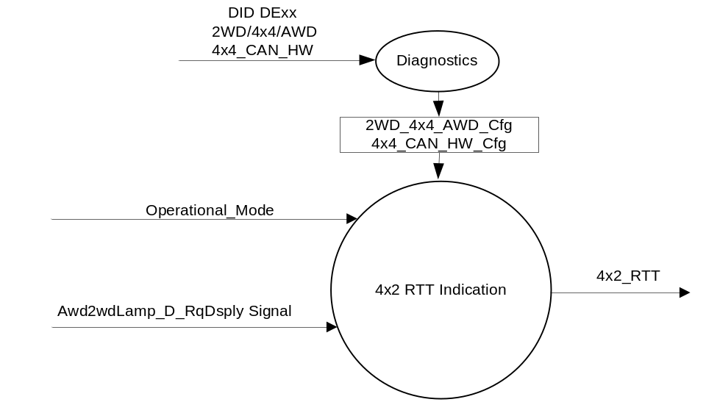

Inputs

      - INTERNAL:
            - 2WD_4x4_AWD_Cfg
            - 4x4_CAN_HW_Cfg
            - Operational_Mode

      - MUX message on the CAN Bus

- Signal Awd2wdLamp_D_RqDsply
ID | Size  (bits) | Detail | Units | Res. | Offset | State Encoded | Min. | Max.
Awd2wdLamp_D_RqDsply | 2 |  | SED | 1 | 0 |  | 0(0x0) | 3 (0X3)
 |  | Off |  |  |  | 0x0
 |  | On |  |  |  | 0x1
 |  | Flash |  |  |  | 0x2
 |  | Not_Used |  |  |  | 0x3

Outputs
4x2_RTT, which is used to control the state of the RTT.

Function/Performance

Operational Modes

Mode | Differentiating Vehicle Conditions
Sleep Mode | 4x2 RTT OFF
Limited Mode | 4x2 RTT OFF
Normal Mode | 4x2 RTT ON/OFF
Crank Mode | 4x2 RTT ON/OFF

The above table references the setting of the RTT flag as per this section. However, the actual RTT display operational modes are displayed in the Message Center section of this SPSS.

Voltage Levels

Refer to the Cluster Features table located in the Operational Modes and Voltage Range Strategies section in this SPSS

Human-Machine Interface

Visual

Indicator Graphics / Display Format

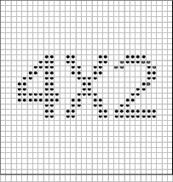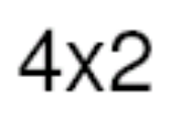
Pixel Definition

For actual symbol definition see abbreviations table in the approved Symbols list as per 03-0685 ARL requirement.

Indicator Color Coordinates

Amber - Reference SDS IL-0017/IS-0379

Indicator Characteristics

4x2 RTT

Audio

None.

System Accuracy

The 4x2_RTT shall change the state of the Telltale within 100ms of a state change as indicated in the state matrix reference 1.3.5.1 Subsystem Algorithm Flowchart / State Diagram.

Operation: Performance and Functional

Subsystem Algorithm Flowchart / State Diagram

Figure 1.1 4x2 RTT Configuration Flowchart

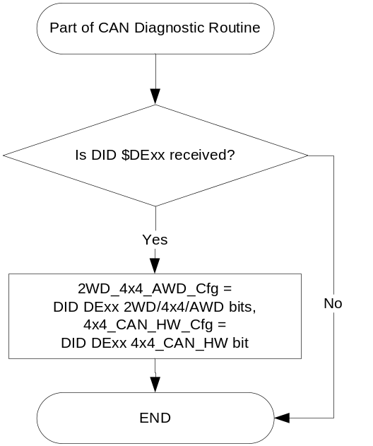

- State Matrix for 4x2_RTT

Operational_Mode | 2WD_4x4_ AWD_Cfg | 4x4_CAN_ HW_Cfg | Awd2wdLamp_D_RqDsply (HS CAN Signal) | 4x2_RTT
Normal or Crank | 4x4 (0x1) | CAN (0x1) | Transition  OFF(0x0) →ON (0x1) | Active for 4 seconds then Inactive
Normal or Crank | 4x4 (0x1) | CAN (0x1) | Transition  FLASH(0x2) →ON (0x1) | Active for 4 seconds then Inactive
Normal or Crank | 4x4 (0x1) | CAN (0x1) | ON (0x1) | Active/Inactive  As per rows above
Normal | 4x4 (0x1) | CAN (0x1) | Declared Missing | Inactive
All other cases |  |  |  | Inactive

Operation Description (supports algorithm flowchart /state diagram)

- 4x2 RTT illumination is mutually exclusive with the 4x4 Auto RTT, 4x4 Low RTT, and 4x4 High RTT, as such 4x2 RTT, 4x4 High RTT, 4x4 Low RTT, and 4x4 Auto RTT are shown on the same space within the TFT.

- In the case of having more than one of the above RTTs active at the same time, the highest priority RTT will be illuminated. The priorities are as follows:

- 4x4 Low RTT (Highest Priority)
- 4x4 High RTT
- 4x4 Auto RTT
- 4x2 RTT (Lowest Priority)

- W785 will be the RTT display when 4x2_RTT is active.

- Intent is if 4x4_CAN_ HW_Cfg = HW then 4x2_RTT flag is always Inactive.

Function Safety Classification (EMC)

Class B

Memory Storage

Parameter Name | Description | Value at  Battery Connect | Value at  Module Wake-up
4x2_RTT | Used to control the state of the RTT | Inactive (0x0) | Inactive (0x0)
Awd2wdLamp_D_RqDsply Signal | CAN signal sent from TCCM. | OFF (0x0) | OFF (0x0)
2WD_4x4_AWD_Cfg | State indicator for feature presence controlled via CAN at EOL at VO plant. | Use Stored Value | Use Stored Value
4x4_CAN_HW_Cfg | State indicator as to whether 4x4 states are received via CAN or HW to IPC. | Use Stored Value | Use Stored Value
Operational_Mode | 4 state indicator for cluster operational mode | Limited | Limited, Normal or Crank

Prove Out

None

Reconfigurable Telltale

Yes

Message Center Message

None

Error Handling

Missing Message Strategy

The signals will be declared missing as per the Diagnostics section of this SPSS.

DTCs states and history will be determined as per the Diagnostics section of this SPSS.
If the 2WD_4x4_AWD configuration is not 4x4 (01), OR if the 4x4_CAN_HW configuration is not CAN, the cluster shall never log a missing message DTC due to this feature.

Diagnostics

Self Test

None

Engineering Test Mode

Reference section “Dealer / Engineering Test Mode (ETM)”.

Part II Performance

DID DE xx
Block  Num | Block Description | Size (bits) |  | Byte(s) | Bits | State: Description | "0" | "1" | Default | Comments/  Information
PACKETED BLOCKS
xx | Option Content (B&A) |  |  | * | 2 | 2WD/4x4/AWD | encoded | encoded | 01 - 4x4
 |  |  |  |  |  | - 00 - 2WD | encoded | encoded
 |  |  |  |  |  | - 01 - 4x4 | encoded | encoded
 |  |  |  |  |  | - 10 - AWD | encoded | encoded
 |  |  |  |  |  | - 11 – Not Used | encoded | encoded
 |  |  |  | * | 1 | - 4x4_CAN_HW | Hardwired | CAN | CAN | Set to Hardwired for MSOS vehicles only.
*Byte and bit location to be identified in Part II Specification for this cluster

Reference Specification

FO-0007 FOUR WHEEL DRIVE MODE DISPLAY
FO-0008 FOUR WHEEL DRIVE FAULT INDICATOR

IS-0001 WARNINGS/INDICATORS/DISPLAYS PROVEOUT
IS-0046 INSTRUMENTATION MATERIAL RESISTANCE TO CLEANING
IS-0052 OPERATING VOLTAGES - FUNCTIONAL/PERFORMANCE
IS-0069 FUNCTIONAL IMPORTANCE CLASS
IS-0324 WINDSHIELD & OTHER REFLECTIONS
IS-0327 WARNING INDICATOR EVALUATION
IS-0329 FLICKERING OF LAMPS
IS-0379 NORTH AMERICAN WARNINGS AND INDICATORS STRATEGY

IL-0017 TELLTALE AND INTERIOR ILLUMINATION COLOR
IL-0021 CRAFTSMANSHIP - DISPLAYS
IL-0023 CLARITY/LEGIBILITY/READABILITY
IL-0025 INTERIOR ILLUMINATION INTENSITY
IL -0027 VISUAL CONTRAST
IL -0043 OPERATIONAL ENVIRONMENT FUNCTIONALITY
IL -0045 COLOR
IL -0047 TELLTALE; INDICATOR AND DISPLAY LIGHT INTENSITY
IL -0048 ILLUMINATION ACCEPTABILITY

03-0661 PLACEMENT: CONTROL AND DISPLAY LOCATIONS
03-0662 PLACEMENT: LOGICAL GROUPING FUNCTION AND USAGE
03-0664 PLACEMENT: DOWN VISION TO COMPONENTS WITH HIGH VISUAL DEMAND
03-0665 PLACEMENT: EXPECTED LOCATIONS OF CONTROLS AND DISPLAYS VDS
03-0670 INTERIOR VISIBILITY
03-0671 INTERIOR VISIBILITY: REFLECTIONS FROM COMPONENTS & SURFACES
03-0672 INTERIOR VISIBILITY: REFLECTIONS IN DISPLAYS
03-0673 INTERIOR VISIBILITY: VISUAL OBSCURATIONS
03-0674 INTERIOR VISIBILITY: ILLUMINATION CONTROLS / DISPLAYS
03-0675 INTERIOR VISIBILITY: VEILING GLARE
03-0677 INTERIOR VISIBILITY: SUNLIGHT WASHOUT
03-0681 IDENTIFICATION: CHARACTER AND SYMBOL SIZE
03-0682 IDENTIFICATION: LEGIBILITY
03-0685 IDENTIFICATION: SYMBOLS, ABBREV FOR CONTROL
03-0721 LOGIC OF OPERATION: OPERATIONAL STEREOTYPES
03-0722 LOGIC OF OPERATION: INTERPRETATION
03-0723 LOGIC OF OPERATION: USE OF SYSTEMS WITH VISUAL DISPLAYS

Revision History

SPSS Module Revision History

Revision Level | Name | Change Description | Date
1.0 | J. Blatchford | Initial Release. At the time of this release 2017 P558 is the only CGEA1.3 program known to implement MSOS 4x4. | 3/10/14
2.0 | S. Watkins | An issue was found on MY17 P552 Raptor. The 4x4 module sends state 0x2 of the CAN signal for Raptor. Thus, the truth table needs to be updated.  This should not be an issue for P558, but updating this STSS for consistency with 4x2 Fixed Dedicated RTT - CGEA1.3_v2.0.doc.  - Section 1.3.5.1 – Table 1.1 added 2nd row. | 4/26/2016

